Aesthetics of Landscape:
- How our cultures have taught us to look at the landscapes
- Not just beautiful or ugly from personal thought
- Out culture teaches us certain standards of natural beauty
- Culturally constructed standards:
  - through different cultures (space)
  - over history (time)
  - Tourist Gaze
- Oxford Concise Dictionary 1964
- Aesthetics: belonging to the appreciation of the beautiful
  - Greek: aisthetikos means perceive, accordance with principles of good taste
- Picturesque: fit to be the subject of a striking picture (Italian: pittore means painter)
- Sublime: to inspire awe or wonder
- The Tourist Gaze:
  - John Urry in his very influential 1990 book, The Tourist Gaze (London)
  - Tourists consume and create news, according to some aesthetic
  - They objectify what they see (genres, peasants, not as individuals)
  - These features of a view are part of the other
  - The tourist gaze commodifies what it sees
- Tourists create the scenic
  - “The eyes that see nature as scenic are the eyes of the modern tourist, scanning the world as a source of interest and aesthetic pleasure”
  - Tourist gaze turns what might be a mundane experience into a tourist experience of special value (1992)
- Aesthetics:
  - Culturally/socially constructed: we are taught how and what to see
  - Change through time:
    - Grand Canyon, sublime or spectacular (attraction)
    - Landscape garden
    - Niagara Falls
    - The Rockies
    - Glaciers
- William Cronon: rise of sublime landscape mostly due to the sense of a growing loss of this landscape:
  - Creation of national parks
  - Celebration of sublime in landscape art

- European Landscape Gardens:
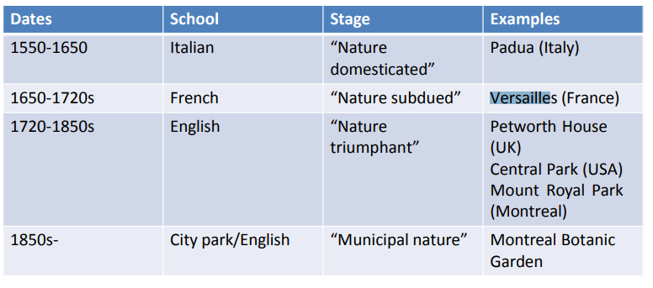
  - Shows how each culture and time period establishes what is considered to be beautiful
  - Has gone through 4 major changes (1550-1850)
    - Italian, French, English, City Park
  - The Italian Garden: Nature Domesticated (1550-1650)
    - Padua: small enclosed botanic garden to keep nature inside, organized
    - Palazzo gardens
    - Monty Don, France
    - Isola Bella, Lake Maggiore, Italy (1632)
  - French Nature Subdued (1650-1720)
    - Great Garden at Versailles
    - Garden now seen as a theatre for the king to show his power
    - Monty Don, Vaux le Vicomte
  - English Garden: Nature triumphant (1720-1850)
    - Wotton House
    - People started to want more natural look for nature
    - Irregular planting, hills, not subdued nature
    - Petworth House
    - Blenheim Palace, Oxford, UK (Lancelot)
    - Floors Castle, Roxburghshire in Scotland
    - Parc du Mont-Royal
    - Thomas Jefferson’s Garden (1816) at Monticello, Virginia
  - The City Park: Municipal nature (1850-present)
    - Suburban front lawn
    - Golf garden
- John Wylie Landscape (2007):
  - Encounters with landscapes create a sense of affect between person and landscape
  - Landscape itself can have an agency
- Islamic Gardens:
  - Amber Fort (1750)
  - Cairo’s Azhar Park (2005)
- Chinese Gardens
- Place marketing:
  - Views can be marketed as tourist attractions
  - Natural phenomena become commodified
  - Niagara Falls
  - Grand Canyon
  - Australia’s Uluru Rock
  - The Oglas

